**1. Read and translate the text:**

**SMART HOUSE**

What is a “smart house”? Today it is a rather trivial system of lighting control, consisting of several dimmers. A home theater with components controlled by a smart remote or a sensor panel is also part of this system. One can also add a climate control system, a fire alert, curtain control, remote controls on the Internet, etc., etc…

Automated systems are no longer luxury: they have become a must-have. Today it is not enough to develop house layout, install the basic services and carry out “turnkey” interior design. The market price for lodging equipped with technical devices according to the latest trends, will be considerably higher, although it doesn’t require huge investments. A house or an office equipped with cutting-edge technologies may be viewed as successful investments.

The installation stage includes cable network laying on the site (installation of cable trays, boxes, PVC-pipes, preparation of ceilings, floors, walls and bridgings, mounting rack cases for AV-devices, in-built panels for electrical control units and cross-panels). Cable laying includes a wide spectrum of wiring services – power cables of 220 V, phone and computer networks (including Wi-Fi networks for wireless Internet), control system cables, multiroom cables, air and satellite TV, intrusion alert, and video monitoring. (see Fig.1).

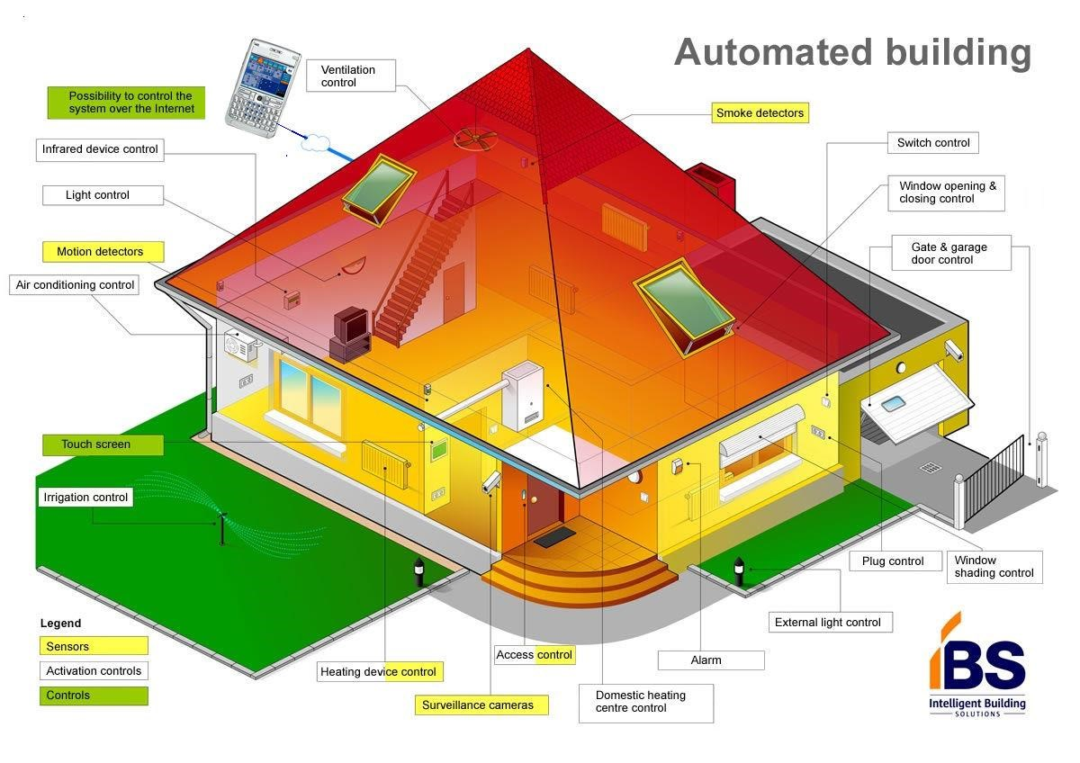

Fig.1. Smart House

At the end of this stage capacity of the components is tested. It is important to understand that it will be difficult to introduce changes in equipment configuration later. After the equipment has been installed, it is programmed and prepared for commissioning. Changes may be introduced in the user interface, e.g. the basic sets of control buttons on sensor panels may be replaced by unique ones, tailored for a particular client, or the button functions may be changed.

A “Smart House” emerged as a result of accumulation of achievements in different home technology segments.

The market for correspondent services has already been formed successfully. This was possible due to rapid software development, as well as the fact that technical components became cheaper and more unified. Even 10 years ago “smart house” technologies from different suppliers were totally incompatible, the systems were “closed”, and maintenance expenses equaled the cost of installation. Today everything is cheaper, easier, and in a sense more reliable.

Smart offices occupy a significant segment in the market of automated systems. The problem of providing comfortable working conditions and at the same time optimization of office maintenance costs is rather acute, that’s why SH systems are introduced here more and more actively in this area.

It is now hard to imagine a modern office without an automatic personnel accounting system (arrival-departure) and access control. Electronic devices allow to eliminate mistakes, associated with human factor leaving the supervisory role to the staff. At the same time the price for the simplest, but efficient control systems may be quite modest, comparable, for example, with office equipment expenses.

Another reason for “smart offices” being so popular is the opportunity they offer for power saving (up to 40%!), which is especially relevant for large offices. A computer itself (using motion detectors) or with the guards’ assistance (a network of video cameras) identifies the empty rooms, turns off the lighting, ventilation and heating, switches the lifts to night mode – careful disposal of resources allows the system pay for itself very fast.

Do we need to make everything so complicated: isn’t it enough to just turn off the central power switch in the office for power saving? This works for local power loads (light, computers, conditioners), but not for the central heating and ventilation. No need to mention that a square meter in a smart office is more expensive than an ordinary one…

Smart house technology isn’t just a luxury for the wealthy. Those who are energy savers and environmentally minded will probably end up using at least some smart house features in their own homes.

1. **Study the list of terms below and then proceed to the exercises*.***

|  |  |
| --- | --- |
| аutomated systems | автоматизовані системи |
| AV device | аудіовізуальний пристрій |
| bridging | перекриття (напр., прольоту будинку) |
| cable network laying | прокладка кабельної мережі |
| capacity | здатність; (функціональні) можливості; продуктивність; ємність |
| cutting-edge technologies | передові технології |
| dimmer | регулятор світла |
| fire alert | пожежна тривога |
| hand-held remote | пульт дистанційного керування |
| humidity | вологість |
| incompatible | несумісний |
| intrusion alert | попередження вторгнень |
| key-pad | (мала) клавіатура |
| layout | планування, план, розташування |
| luxury | розкіш; предмет розкоші |
| maintenance expenses | вартість технічного обслуговування |
| mounting | монтаж |
| PVC-pipe | поліхлорвінілова трубка |
| turnkey | готовий до здачі "під ключ" |
| unified | єдиний; уніфікований |
| Wi-Fi | вай-фай, бездротовий доступ в інтернет (за назвою торгової марки) |

**3. Translate into English*.***

1. Розумний дім; 2) аварійне джерело живлення; 3) конструкція тунельного типу; 4) регулювати освітлення; 5) фотогальваничні панелі; 6) дроти та електронні адаптери; 7) сонячний паровий котел (бойлер); 8) сховані датчики; 9) контролювати споживання; 10) вікна та штори, що приводяться у дію електродвигуном; 11) комунальні служби; 12) головна панель управління; 13) бак; 14) контролювати температуру.

**3. Fill in the gaps with the terms in the box. Translate the sentences into Ukrainian.**

network, comfort, tank, expenditure, sensors, controller, presence, solar, electronic adapters, hand-held remotes, meters, consumption, rainwater, photovoltaic panels, technological, automation, temperature, electrical apparatus

1. Smart houses with home …… systems have progressed from dream to reality.
2. The goal of a smart house is to coordinate all domestic systems to minimize the …… of energy and maximize the …… of its occupants.
3. It is filled with dozens of hidden ……. monitoring ……., humidity, airflow, carbon dioxide, and even human ……. in the house.
4. On the roof of a smart house, a tunnel-like structure collects ……, which is sent to a holding …….
5. A ……. boiler heats washing and bath water in the smart house.
6. Gas, electricity, and water ……. are integrated with the ……. so that utilities and homeowners can monitor ……..
7. Its sensors are part of a ……. linking three PCs with appliances, motordriven windows and blinds, humidifiers, and so on.
8. We interact with the home automation system via telephone, …….. , keypads, touch screen televisions, and voice commands.
9. Computers and sensors linked by miles of wire and ……, enable the smart house to control security systems, entertainment centers, appliances, lights, blinds, heating and cooling systems, swimming pool systems, and other systems that can be activated by …………… .
10. In Japan, an experimental smart house has been built that seems warm and inviting – anything but ………… .
11. A solar boiler heats washing and bath water in the smart house, and a row of …………… collects solar energy to charge batteries for emergency power.